Robert Schumann Sonata in A Minor, Op. 105
(1810-1856) (1851)
I. Mit Leidenschaftlichem Ausdruck
II. Allegretto
III. Lebhaft

Zili Li Fisherman's Harvest
(1938- ) (1972)

Charles Camille Saint-Saëns Introduction and Rondo Capriccioso
(1835-1921) (1863)

Manuel de Falla/ arr.Kreisler Danse Espagnole, La Vida Breve
(1876-1946) (1905)

Schumann was a German composer, music critic and aesthete. He embodies the romantic style, particularly in his piano music. This sonata was composed in the 11th year of his marriage to Clara, one of the foremost concert pianists of the day, and they had seven children. The piece seems to depict his astounding love for Clara, deeply heartfelt, at times passionate, at times calm and thoughtful.

Zili Li is a contemporary Chinese violinist, educator and composer. He has cultivated a large number of outstanding musicians. Meanwhile, he has composed a great deal of Chinese style music for violin. Fisherman's harvest is based on a Fisher’s Song in Chao-Shan region of China. This work depicts joyful scenes, which fishermen come back in the evening and have a great harvest. Then people go home and have rest and the small village becomes tranquil and peaceful.

Saint-Saëns was an old-school romantic, a pianist, organist and prolific composer. He held a very influential place in French artistic circles. This work was dedicated to the Spanish virtuoso violinist Sarasate, who was much admired by Saint-Saëns. The sentiments of the piece vary between melancholy and sparkling energy, but there is always elegance and charm. The Spanish spirit is brilliantly captured in honour of the dedicatee.

Falla was one of the most significant Spanish musicians during the first half of the 20th century and his works have strong national colour. La Vida Breve is the title of a two act opera, a love tragedy. It depicts how a gypsy girl Salud cannot be accepted by her lover Paco and finally falls dead at his feet in desperation. This short dance is the only part famous today, originally an orchestral interlude which Falla transcribed for solo piano, and Fritz Kreisler in turn transcribed to play himself.

VIOLIN CONCERT
Student’s Lunchtime Concert

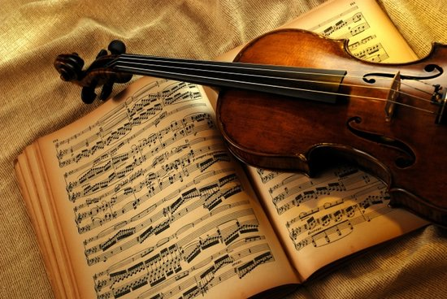

1pm Monday 25.02.2013
Turner Sims Southampton

Yiyao Wu was born in Nantong City in China. She started playing the violin at the age of 6 and studied violin performance in Nantong University, graduating in 2012. She won the first place in competition of ‘National youth art performance’ in 2010 and ‘The Sixth China Young People Festival’ in 2011. Yiyao is currently studying for a Masters degree in performance at the University of Southampton.

